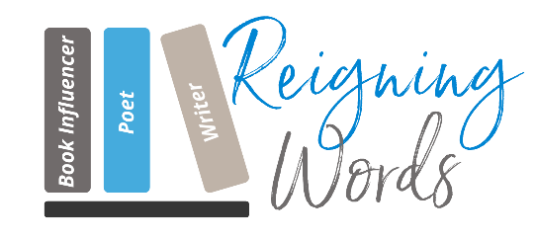
www.reigningwordsnyc.com I Email: reigningwordsnyc@gmail.com
_____________________________________________________________________

About Reigning Words, LLC:
Thank you so much for your interest in Reigning Words reviewing your book. We are a company that specializes in writing comprehensive and thoughtful book reviews. We ensure you a review that will be honest and our presentation of that review will be respectful and tactful. For reviews that are not favorable, we engage you in a discussion and allow you the choice to post or not.
If you would like more information, please type in the information below, print out, scan, and email the form to www.reigningwordsnyc@gmail.com:

Author’s Information:
Author’s Printed Name :
Email address:
Website:
Book Title:
Genre:
If requesting an ARC Submission, type yes:
Book Release Date?
If requesting a Book Review, please type yes:
Social Media Platform Addresses:
Instagram:
FaceBook:

